Use Report Builder to identify which CLIENTS are missing an email address for the MAIN CONTACT

Launch Report Builder by clicking BUILD NEW REPORT.

Give a name to your new report. Choose who should be able to access it. And choose where you want to save this report when you export it.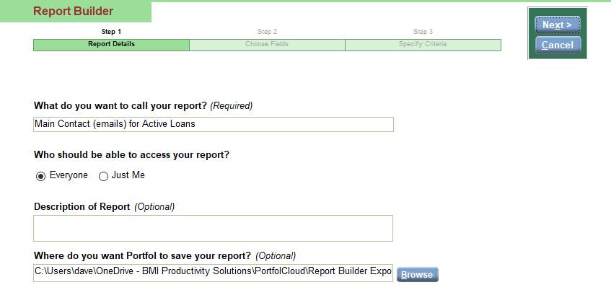

Choose which fields you want to appear in the report. For this example we are going to choose a few fields from the CLIENT table: Client #, Client Name, Main Contact for this Client, Main Contact E-Mail (Client).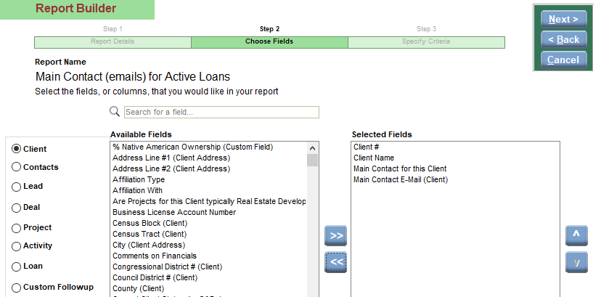
And we are also going to choose at least one field from the LOAN table: Loan #.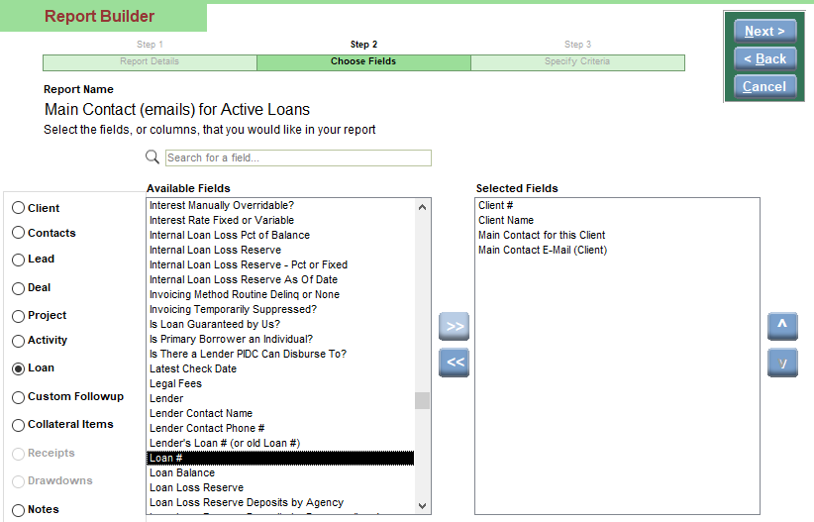
Here is what your SELECTED FIELDS section should look like.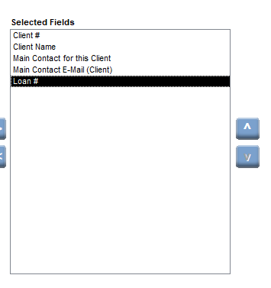
On the final screen we are going to add a CRITERIA filter. We only want to see clients that have an active loan so choose the LOAN STATUS and set it EQUAL to ACTIVE.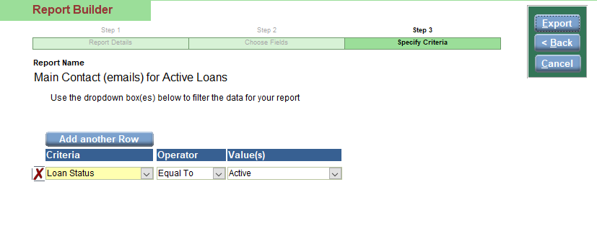

When we click EXPORT we’ll then see an Excel file with our chosen data. You can identify which clients need a Main Contact Email from this. If you’d like to clean up this Excel file a little go on to the next steps.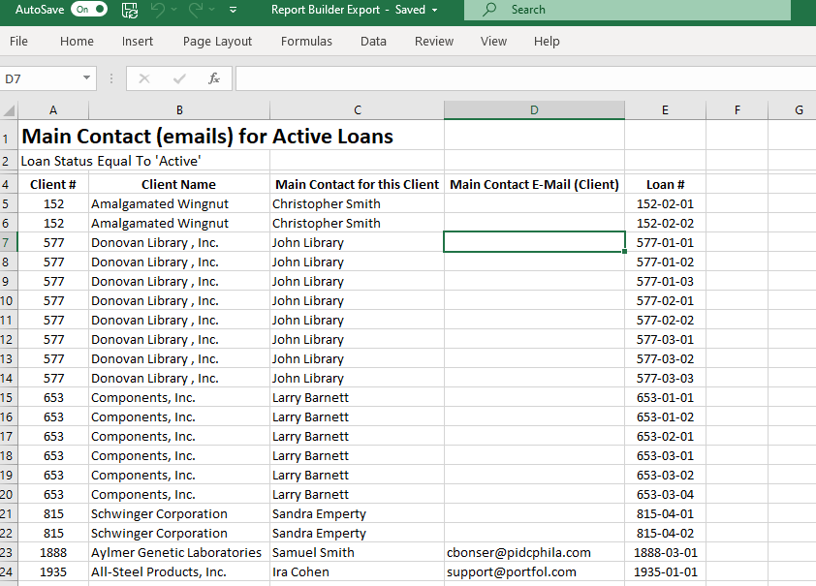

To clean up the Excel file and only show clients once, highlight your Client # column, click on the DATA menu at the top and choose ADVANCED FILTER. Check the UNIQUE RECORDS box and click OKAY.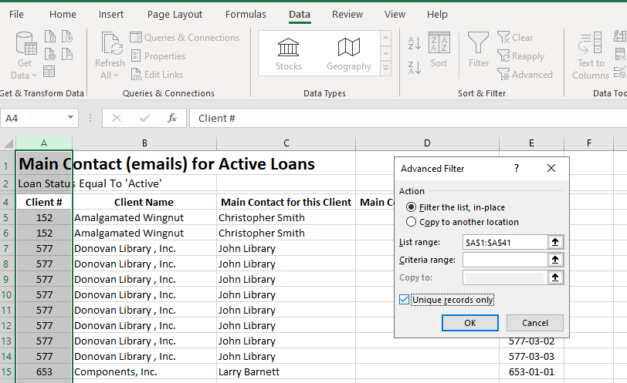
This now displays a single CLIENT line for each client. You can delete the LOAN column as it is no longer needed.